

Thanet Road Club
Presents

A 10 MILE TIME TRIAL
on
SUNDAY 25th July 2021 AT 07:00 Hrs on the Q10/30
Promoted for and on behalf of Cycling Time Trials under their rules and regulations

Timekeepers: Start - Terry Fearn. Finish - Andy McCall & Christine Burrows, (Thanet Road Club)
Event HQ: Spires Academy in Bredlands Lane, Sturry. For satnav users the postcode is CT2 0HD.
HQ open from 6am
Event Secretary: Michael Friend, 11 Quex View Road, Birchington, Kent, CT7 0DZ.
Tel: 07921 491 658 Email: michael.john.friend@hotmail.com

PLEASE NOTE THE FOLLOWING COVID-19 GUIDANCE. SOCIAL DISTANCE RULES APPLY TO ALL RIDERS, HELPERS, MARSHALLS AND TIME KEEPERS.

PLEASE BE RESPECTFUL AND KEEP US ALL SAFE.

PLEASE DO NOT ATTEND THE EVENT IF YOU OR ANY MEMBER OF YOUR SUPPORT CREW OR FAMILY SHOWS SYMPTOMS OF COVID 19 OR FEELS UNWELL.
IN THE INTERESTS OF YOUR OWN SAFETY
Cycling Time Trials and the Event Promoters, strongly advise you to wear a HARD SHELL HELMET which meets an internationally accepted standard. This is compulsory for junior riders.
It is also mandatory that a working rear light, either flashing or constant, is fitted to the machine in a position visible to following road users and is active whilst the machine is in use

Q10/30 Course Details:-
Start at eastern end of 1st drain in May Street, just before entrance to Southern Water Services Depot. (TR208673). Proceed via service road to join A299, continue on A299 to St Nicholas at Wade RAB, and take 3rd exit to Monkton RAB (5.472 miles). Turn and retrace A299 to finish west of the Roman Galley ex-PH on slip road to Chislet/Marshside, 4 yards before last LP FUV010 before turning left on slip road. (TR225676).
Course Records: Men: 18:04 Christopher Fennell, Women 19:51 Emma Lewis

The below is the Strava map of the course - https://www.strava.com/segments/1707344

Please ensure you are familiar with the course before riding

The onus of keeping to the course is with the rider

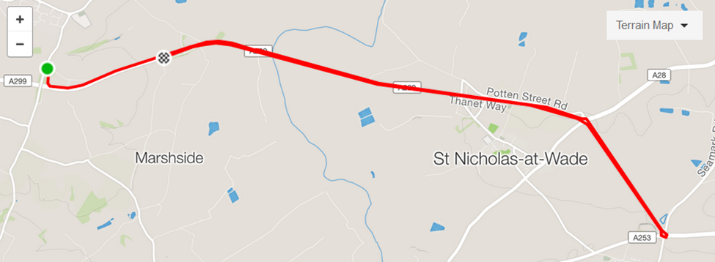

The following prizes will be awarded

Men Fastest on Scratch

1st £20
2nd £15
3rd £10

Fastest on Age Std.

1st £20
2nd £15
3rd £10
Women Fastest on Scratch

1st £20
2nd £15
3rd £10

Fastest Junior / Juvenile

1st £20
2nd £15
3rd £10

Fastest Team of 3 (Total Time)

1st £30 (£10 each)

One prize per entrant (excluding team).

INFORMATION FOR COMPETITORS
EVENT HEADQUARTERS: We will be using the Spires Academy in Bredlands Lane, Sturry. For satnav users the postcode is CT2 0HD. You cannot miss the new buildings.
Directions to Race HQ: From the Thanet Way A229 leave at junction SP Hillborough, Reculver, Hoath and Chislet.
Turn left into Sweechbridge Road, left at T junction into Heart in Hand Lane. Follow this road for 4 miles then turn left into Bredlands Lane (Signed). The Spires Academy is 0.5 miles on the left.
Coming from Canterbury take the A28 towards Thanet. Pass through Sturry and take the first left after Perry`s Vauxhall Dealership into Bredlands Lane. The new school is on the right.

Please allow at least 20 minutes to get to the start from the HQ. It is 4½ miles away.

To get to the start turn right out of the car park, down the hill to the T junction, turn right and continue for four miles to reach the start
After finishing proceed up the hill on the A299 for approx. 1 mile, turn off at sign for Reculver, then left at T junction to return to HQ.
Numbers and signing on/off sheet will be at the HQ (NOT THE START). Signing may be done outside. Please bring your own pen for signing on and your own safety pins if needed. Please use the sanitiser. After finishing and signing off please place your number in the bucket of disinfectant provided.
Masks to be worn when at the HQ and no spectators allowed.
Competitors must sign on and off at the HQ or they will not be allowed to race. Failure to do so will result in the competitor being recorded as DNF.
Toilets are located inside the HQ hall to the left as signposted. We will operate a one-way system please queue following social distancing measures. Please come ready to compete and not use the toilets as a changing facility.
Please keep noise to a minimum so as not to disturb the local residents.
There will be no results or prizes at the HQ. Please do not congregate after the race, head home once finished. Results will be on the CTT website after the event and prize winners will be contacted by the event organiser for distribution.
No warming up on the course please once the event has started. No U turns will be permitted on roads adjacent to the start and finish areas whilst the race is in progress.

No rider should use a turbo trainer or rollers in the headquarters parking area or on adjacent roads. Anyone failing to comply with this restriction risks disqualification.

Competitors and their helpers must not park in the vicinity of the start or finish. Under no circumstances should competitors approach the time keepers.

REAR LIGHTS. No competitor shall be permitted to start the event unless they have affixed to the rear of their machine a working rear red light, either flashing or constant, that is illuminated and in a position that is clearly visible to other road users.

Riders please be aware of regulation - Reg. 20(a) which covers the issue of HEAD DOWN riding – Head down riding will NOT be tolerated.

HEADS UP AND RIDE SAFE

No. | Start | Name | Club | Cat | Age Std.
3 | 07:03 | Peter Huckstep | Thanet RC | V | 29:30
4 | 07:04 | Fiona Howarth | VC Deal | WV | 29:41
5 | 07:05 | Bill Hawkes | Thanet RC | V | 27:07
6 | 07:06 | Enrico Seccatore | VC Deal | V | 27:37
7 | 07:07 | Simon Friend | Thanet RC | S
8 | 07:08 | Paul Flaherty | VC Deal | V | 27:18
9 | 07:09 | Jennifer Fearn | Thanet RC | WV | 32:23
10 | 07:10 | Martin Jones | Colour Tech RT | V | 26:51
11 | 07:11 | Christopher Bax | Thanet RC | V | 29:08
12 | 07:12 | Tracy Wilkinson-Begg | TWB - On Time Race Team | WV | 29:54
13 | 07:13 | Tanya Scott-Nason | Thanet RC | WV | 29:23
14 | 07:14 | Reg Smith | Colour Tech RT | V | 30:20
15 | 07:15 | Antony Bee | Wigmore CC | V | 27:30
16 | 07:16 | Marc Dunn | Woolwich CC | S
17 | 07:17 | Matt Bristow | VC Deal | V | 26:51
18 | 07:18 | Matt Nunn | Medway Velo Club | S
19 | 07:19 | Colin Inett | Thanet RC | V | 31:39
20 | 07:20 | John Cockrill | Abellio - SFA Racing Team | S
21 | 07:21 | Paul Kirkness | Thanet RC | V | 28:49
22 | 07:22 | Robert Giles | PMR | V | 30:07
23 | 07:23 | Mike Perry | Thanet RC | V | 30:35
24 | 07:24 | Colin Marshall | 34 Nomads CC | V | 28:22
25 | 07:25 | Paul Burrows | Thanet RC | V | 26:23
26 | 07:26 | Jim O’Leary | GS Avanti | V | 28:22
27 | 07:27 | Andy Burrows | Thanet RC | V | 31:05
28 | 07:28 | Jonathan Hemming | Addiscombe CC | V | 27:01
29 | 07:29 | Reuban Davey | Abellio - SFA Racing Team | S
30 | 07:30 | Dan Martin | Thanet RC | S
31 | 07:31 | Colin Jarman | Southborough & Dist. Whs | V | 29:42
32 | 07:32 | George Lynch | University of Warwick | S
33 | 07:33 | Steven Smith | Medway Velo Club | V | 26:23
34 | 07:34 | Andrew MacPherson | Kingsnorth International Whs | V | 26:10
35 | 07:35 | Tim Kingston | GS Invicta - Eye Level Optical- Herbert Cycles | V | 26:32
36 | 07:36 | Martin Foord | Abellio - SFA Racing Team | V | 27:44
37 | 07:37 | Colin Robinson | Thanet RC | V | 27:12
38 | 07:38 | Gary Ricks | Woolwich CC | V | 28:22
39 | 07:39 | Andrew Booty | Lewes Wanderers CC | V | 27:07
40 | 07:40 | Nicholas Fennell | Thanet RC | S
41 | 07:41 | Natasha Jarman | Southborough & Dist. Whs | WV | 28:33
42 | 07:42 | Abbey Thompson | Suffolk Youth Race Team | WJ
43 | 07:43 | David Smith | VC de Londres | S
44 | 07:44 | Ian Turner | Southborough & Dist. Whs | V | 29:42
45 | 07:45 | Pete Elms | VC Deal | V | 27:12
46 | 07:46 | Eva Zsigoova | ...a3crg | WS
47 | 07:47 | Debbie Percival | Kent Velo Girls/Boys | WV | 30:23
48 | 07:48 | Rob Kennison | Medway Velo Club | V | 27:30
49 | 07:49 | Simon Henderson | Thanet RC | V | 27:37
50 | 07:50 | Kevin Tye | VeloRefined Rule 5 | V | 27:44
51 | 07:51 | Mark Doxey | Abellio - SFA Racing Team | V | 27:07
52 | 07:52 | Paul Smith | VeloRefined Rule 5 | V | 26:46
53 | 07:53 | Neil Gerrard | Folkestone Velo Club | V | 26:06
54 | 07:54 | Martin Brown | 7Oaks Tri Club | V | 27:51
55 | 07:55 | Alex Clay | The Independent Pedaler - Nopinz | WS
56 | 07:56 | Sam Day | CS Grupetto | V | 26:36
57 | 07:57 | Mark Hill | VeloRefined Rule 5 | V | 27:12
58 | 07:58 | David Prom | San Fairy Ann CC Ltd | V | 26:56
59 | 07:59 | Mathew Lister | Folkestone Velo Club | V | 26:06
60 | 08:00 | Christopher Fennell | The Independent Pedaler - Nopinz | S

